LAB ASSIGNMENT-6.5
YASHASWINI
2303A51764
BATCH-12
Experiment 6: AI-Based Code Completion: Working with suggestions for classes, loops, conditionals.
Task Description #1 (AI-Based Code Completion for Conditional Eligibility Check-
Task: Use an AI tool to generate eligibility logic.
Prompt: “Generate Python code to check voting eligibility based on age and citizenship.”
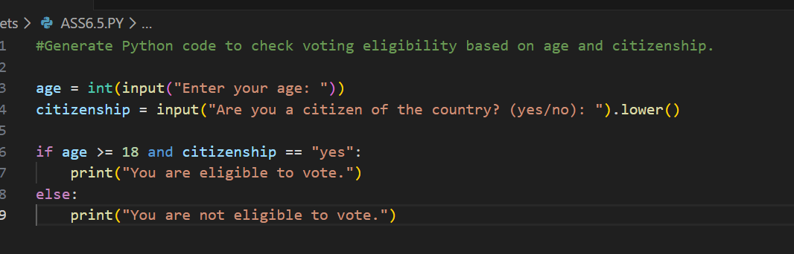
Output:
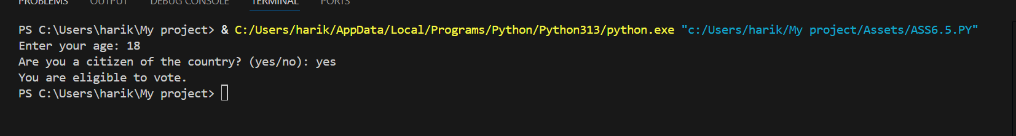
Code generated by AI:
age = int(input("Enter your age: "))
citizenship = input("Are you a citizen of the country? (yes/no): ").lower()
if age >= 18 and citizenship == "yes":
print("You are eligible to vote.")
else:
print("You are not eligible to vote.")
Task Description #2(AI-Based Code Completion for Loop-Based
String Processing)
Task: Use an AI tool to process strings using loops.
Prompt: “Generate Python code to count vowels and consonants in a string using a loop.”
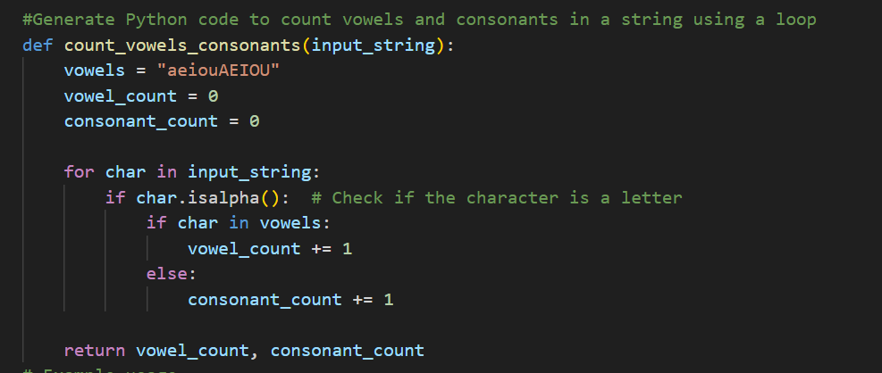
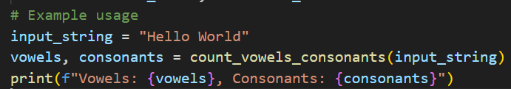
Output:
Code generated by AI:
def count_vowels_consonants(input_string):
vowels = "aeiouAEIOU"
vowel_count = 0
consonant_count = 0
for char in input_string:
if char.isalpha(): # Check if the character is a letter
if char in vowels:
vowel_count += 1
else:
consonant_count += 1
return vowel_count, consonant_count
# Example usage
input_string = "Hello World"
vowels, consonants = count_vowels_consonants(input_string)
print(f"Vowels: {vowels}, Consonants: {consonants}")
Task Description #3 (AI-Assisted Code Completion Reflection Task
Task: Use an AI tool to generate a complete program using classes,
loops, and conditionals.
Prompt: “Generate a Python program for a library management system
using classes, loops, and conditional statements.”
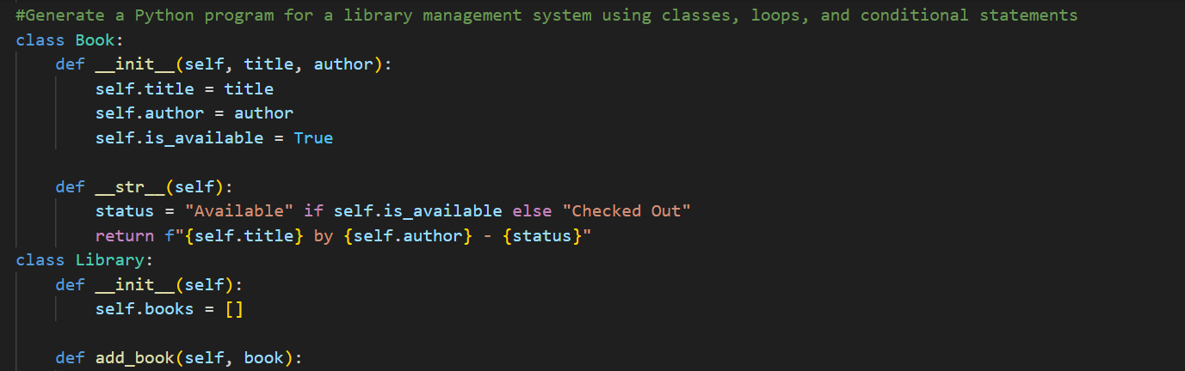
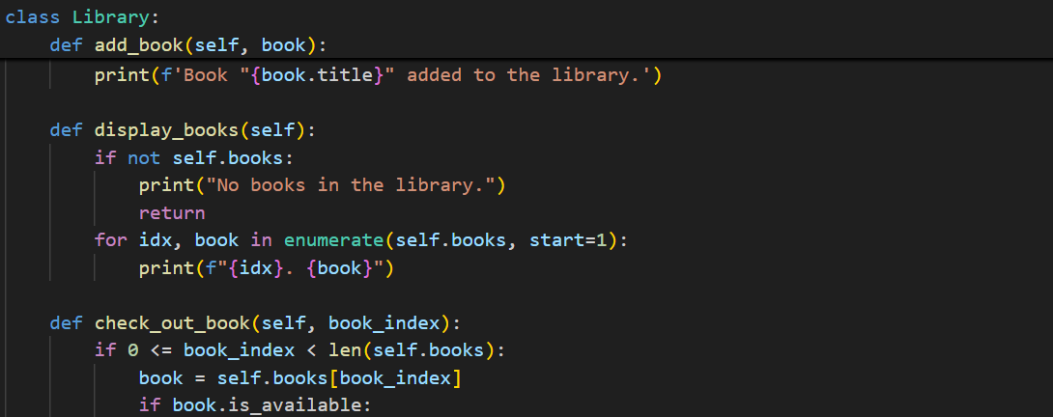
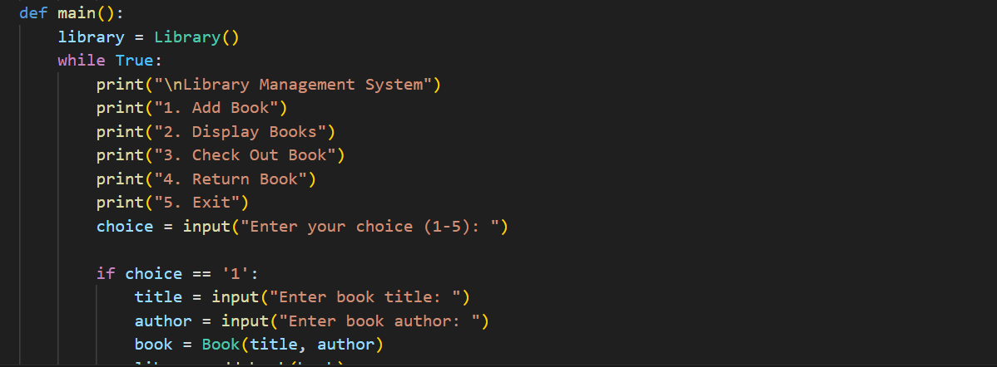
Output:
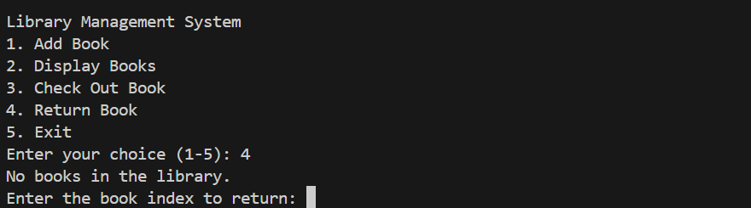
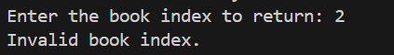
Code generated by AI:
class Book:
def __init__(self, title, author):
self.title = title
self.author = author
self.is_available = True
def __str__(self):
status = "Available" if self.is_available else "Checked Out"
return f"{self.title} by {self.author} - {status}"
class Library:
def __init__(self):
self.books = []
def add_book(self, book):
self.books.append(book)
print(f'Book "{book.title}" added to the library.')
def display_books(self):
if not self.books:
print("No books in the library.")
return
for idx, book in enumerate(self.books, start=1):
print(f"{idx}. {book}")
def check_out_book(self, book_index):
if 0 <= book_index < len(self.books):
book = self.books[book_index]
if book.is_available:
book.is_available = False
print(f'You have checked out "{book.title}".')
else:
print(f'Sorry, "{book.title}" is already checked out.')
else:
print("Invalid book index.")

def return_book(self, book_index):
if 0 <= book_index < len(self.books):
book = self.books[book_index]
if not book.is_available:
book.is_available = True
print(f'You have returned "{book.title}".')
else:
print(f'"{book.title}" was not checked out.')
else:
print("Invalid book index.")
def main():
library = Library()
while True:
print("\nLibrary Management System")
print("1. Add Book")
print("2. Display Books")
print("3. Check Out Book")
print("4. Return Book")
print("5. Exit")
choice = input("Enter your choice (1-5): ")
if choice == '1':
title = input("Enter book title: ")
author = input("Enter book author: ")
book = Book(title, author)
library.add_book(book)
elif choice == '2':
library.display_books()
elif choice == '3':
library.display_books()
try:
book_index = int(input("Enter the book index to check out: ")) - 1
library.check_out_book(book_index)
except ValueError:
print("Please enter a valid number.")
elif choice == '4':
library.display_books()
try:
book_index = int(input("Enter the book index to return: ")) - 1
library.return_book(book_index)
except ValueError:
print("Please enter a valid number.")
elif choice == '5':
print("Exiting the system. Goodbye!")
break
else:
print("Invalid choice. Please try again.")
if __name__ == "__main__":
main()

Task Description #4 (AI-Assisted Code Completion for Class-
Based Attendance System)
Task: Use an AI tool to generate an attendance management class.
Prompt: “Generate a Python class to mark and display student
attendance using loops.”
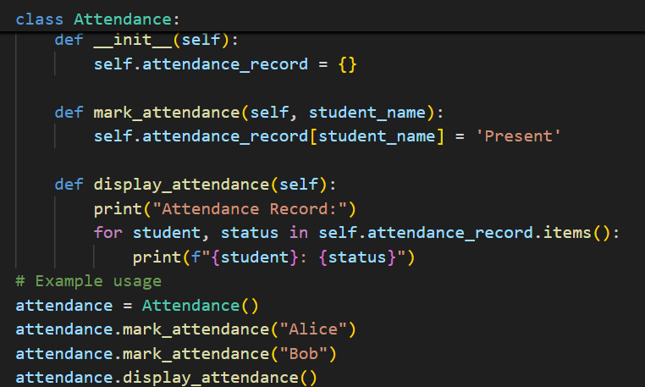
Output:
Code generated by AI:
class Attendance:
def __init__(self):
self.attendance_record = {}
def mark_attendance(self, student_name):
self.attendance_record[student_name] = 'Present'
def display_attendance(self):
print("Attendance Record:")
for student, status in self.attendance_record.items():
print(f"{student}: {status}")
# Example usage
attendance = Attendance()
attendance.mark_attendance("Alice")
attendance.mark_attendance("Bob")
attendance.display_attendance()
Task Description #5 (AI-Based Code Completion for Conditional
Menu Navigation)
Task: Use an AI tool to complete a navigation menu.
Prompt: “Generate a Python program using loops and conditionals to simulate an ATM menu.”
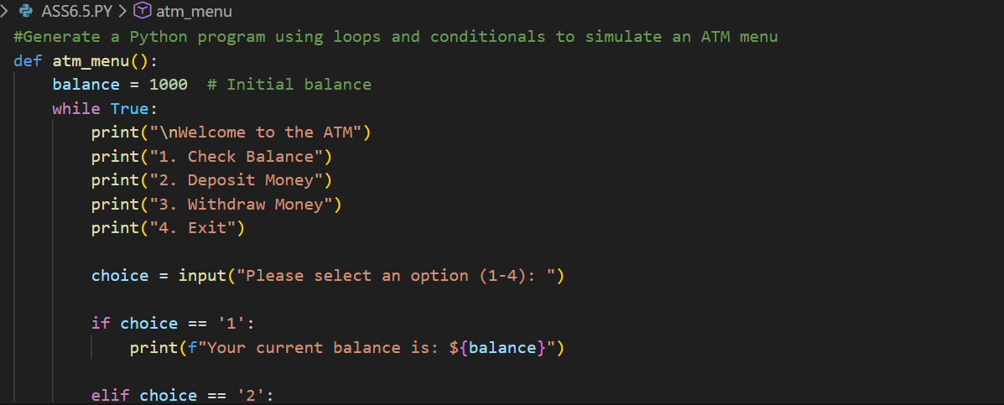
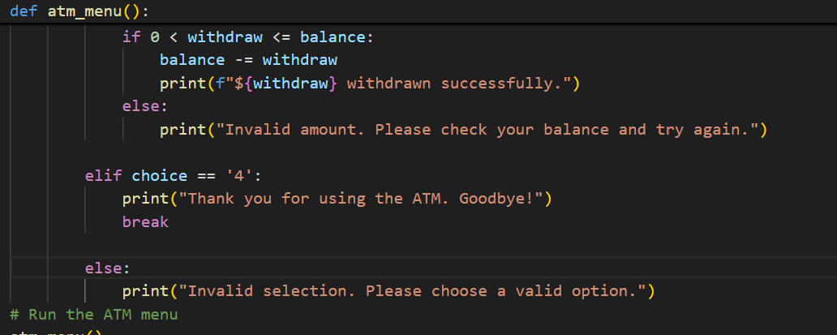
Output:
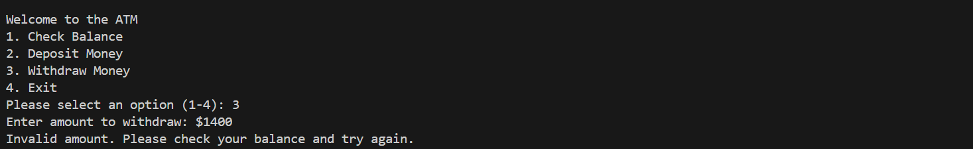
Code generated by AI:
def atm_menu():
balance = 1000 # Initial balance
while True:
print("\nWelcome to the ATM")
print("1. Check Balance")
print("2. Deposit Money")
print("3. Withdraw Money")
print("4. Exit")

choice = input("Please select an option (1-4): ")

if choice == '1':
print(f"Your current balance is: ${balance}")

elif choice == '2':
deposit = float(input("Enter amount to deposit: $"))
if deposit > 0:
balance += deposit
print(f"${deposit} deposited successfully.")
else:
print("Invalid amount. Please enter a positive number.")

elif choice == '3':
withdraw = float(input("Enter amount to withdraw: $"))
if 0 < withdraw <= balance:
balance -= withdraw
print(f"${withdraw} withdrawn successfully.")
else:
print("Invalid amount. Please check your balance and try again.")

elif choice == '4':
print("Thank you for using the ATM. Goodbye!")
break

else:
print("Invalid selection. Please choose a valid option.")
# Run the ATM menu
atm_menu()

